

FACULTY OF INFORMATION TECHNOLOGY
INFORMATION MANAGEMENT DEPARTMENT

A REPORT ON
INDUSTRIAL ATTACHMENT / PRACTICUM / AT

OSOPOX

Submitted to Information Management Department- Faculty of Information Technology in partial fulfillment of the requirements for the degree of bachelor’s degree of the Adventist University of Central Africa (AUCA)

Submitted by: ABUMUKIZA Leon Christian
Student ID: 26478

INTERNSHIP PERIOD: JUNE – OCTOBER 2026

Table Of Contents
PRELIMINARY PAGES - 2 -
DECLARATION - 2 -
APPROVAL - 2 -
ACKNOWLEDGEMENT - 2 -
LIST OF ABBREVIATIONS - 3 -
CHAPTER 1: INTRODUCTION - 4 -
1.1 Background - 4 -
1.2 Objectives of the Internship - 4 -
1.3 Scope of the Report - 4 -
1.4 Methodology - 4 -
1.5 Structure of the Report - 4 -
CHAPTER 2: OSOPOX COMPANY PROFILE - 5 -
2.1 Overview of Osopox - 5 -
2.2 Vision and Mission - 5 -
2.3 Core Services and Products - 5 -
2.4 Organizational Structure - 5 -
2.5 Work Environment and Culture - 5 -
2.6 Location and Contact - 5 -
CHAPTER 3: MAJOR PROJECTS COMPLETED - 6 -
3.1 Introduction - 6 -
3.2 Project 1: TaskFlow (Kanban Board) - 6 -
3.3 Project 2: SecureAuth API (Microservice) - 6 -
3.4 Project 3: Osopox DevPortal (Documentation Hub) - 6 -
CHAPTER 4: SWOT ANALYSIS OF OSOPOX - 7 -
4.1 Strengths - 7 -
4.2 Weaknesses - 7 -
4.3 Opportunities - 7 -
4.4 Threats - 7 -
4.5 Summary - 7 -
CHAPTER 5: CONCLUSION - 8 -
5.1 Summary of the Internship Experience - 8 -
5.2 Skills and Knowledge Gained - 8 -
5.3 Challenges Encountered - 8 -
5.4 Recommendations - 8 -
5.5 Final Remarks - 9 -

PRELIMINARY PAGES

DECLARATION
I, Abumukiza Leon Christian, a student at the Adventist University of Central Africa, Faculty of Information Technology, Department of Information Management, hereby declare that the work presented in this report was carried out during my industrial attachment at Osopox in the Software Development Department from June 8, 2026, to October 14, 2026. I confirm that this report is my original work and has not been submitted for any academic award at this or any other university, except with proper acknowledgment.

APPROVAL
I, RAFIKI GENTIL, hereby confirm that I have supervised the completion of this internship report and that it has been submitted with my approval.
Signature of Field Supervisor:
Date: … / … / 2026

ACKNOWLEDGEMENT
I would like to express my sincere gratitude to OSOPOX for providing me with the invaluable opportunity to intern at their esteemed organization. The experience, mentorship, and practical knowledge gained during this period have been instrumental in my professional development.
Special thanks to my supervisor, RAFIKI GENTIL, and the entire Osopox team members who guided me throughout my journey in full-stack web development, internal tooling, and modern software engineering practices.
Finally, I acknowledge the Adventist University of Central Africa (AUCA), Faculty of Information Technology, for facilitating this industrial attachment and bridging the gap between my academic learning and professional practice.

Abbreviation | Full Form
AUCA | Adventist University of Central Africa
API | Application Programming Interface
AWS | Amazon Web Services
CSS | Cascading Style Sheets
HTML | HyperText Markup Language
HTTP | HyperText Transfer Protocol
IDE | Integrated Development Environment
JS  JWT  REST  SDLC  SQL  UI  UX | JSON Web Token JavaScript  Representational State Transfer JavaScript  Software Development Life Cycle JavaScript  Cascading Style Sheets  Structured Query Language  User Interface  User Experience

LIST OF ABBREVIATIONS

CHAPTER 1: GENERAL INTRODUCTION

1.1 Background

At Adventist University of Central Africa (AUCA), practical training through internships is a vital component of our academic program in Software Engineering. This approach bridges the gap between theoretical classroom knowledge and real-world application. During my internship at OSOPOX, I had the opportunity to apply my academic learning in a professional software development environment, gaining invaluable hands-on experience in modern web technologies and industry practices.

The internship program, supported by dedicated mentors and supervisors, has been instrumental in developing both technical skills and professional competencies. This experience has not only enhanced my understanding of full-stack development but has also prepared me for the transition from academic life to a professional career in software engineering.

Through practical exposure to React.js, Node.js, Express.js, Java Spring Boot, and cloud technologies, combined with the theoretical foundation provided by AUCA, I have developed a comprehensive skill set needed to meet the demands of the modern technology industry.

1.2 Objectives of the Internship
The main objectives of this internship were to:
- Apply theoretical knowledge from coursework in a real-world professional environment.
- Gain practical experience in software development and related IT operations.
- Develop professional soft skills including communication, teamwork, and time management.
- Understand the operational structure and workflow of a technology company.
- Contribute meaningfully to ongoing projects at Osopox.

1.3 Scope of the Report
This report covers the full internship period at Osopox. It presents an overview of the company, the specific tasks and projects I was involved in, challenges encountered, skills developed, and a reflective analysis of the overall internship experience. The report is structured into five chapters, each addressing a distinct aspect of the internship.

1.4 Methodology
Information presented in this report was gathered through direct participation in company activities, observation of internal processes, interaction with colleagues and supervisors, and review of company documentation where permitted. All findings and reflections are based on personal experience during the internship.

1.5 Structure of the Report
The report is organized as follows: Chapter 1 provides the introduction and background. Chapter 2 presents the profile of Osopox as a company. Chapter 3 details the major projects and tasks completed during the internship. Chapter 4 offers a SWOT analysis of Osopox. Chapter 5 concludes the report with key takeaways and recommendations.

CHAPTER 2: OSOPOX COMPANY PROFILE

2.1 Overview of Osopox
Osopox is a forward-thinking technology company operating in the East African region, with its base of operations in Kigali, Rwanda. The company specializes in the design, development, and deployment of innovative digital solutions tailored to the needs of businesses and individuals across various sectors. Osopox positions itself at the intersection of technology and human-centered design, committed to delivering products that are functional, scalable, and impactful.

2.2 Vision and Mission
Vision: To be a leading technology solutions provider in Africa, driving digital transformation across industries through innovation and excellence.
Mission: To empower businesses and individuals with cutting-edge technology tools and services that enhance productivity, improve efficiency, and create lasting value.

2.3 Core Services and Products
Osopox offers a diverse portfolio of technology services, including:
- Custom Software Development: Building tailor-made web and mobile applications for clients across sectors such as finance, health, education, and logistics.
- UI/UX Design: Creating intuitive and visually appealing user interfaces that prioritize user experience.
- IT Consulting: Providing strategic technology advisory services to organizations seeking to modernize their operations.
- Cloud Solutions: Assisting clients in migrating to and managing cloud-based infrastructure.
- Digital Marketing Technology: Developing tools and platforms that support online visibility and customer engagement.

2.4 Organizational Structure
Osopox operates with a lean but highly skilled team structured around functional departments including Software Development, Design, Marketing, and Operations. The company embraces an agile work culture that encourages collaboration, continuous learning, and rapid iteration. Interns and junior developers are integrated into project teams and are given real responsibilities from day one.

2.5 Work Environment and Culture
The work environment at Osopox is dynamic, inclusive, and innovation-driven. The company fosters a culture of open communication, where ideas from all team members — regardless of seniority — are welcomed and considered. Regular team meetings, code reviews, and brainstorming sessions are part of the daily workflow. This culture made the internship experience highly engaging and conducive to personal and professional growth.

2.6 Location and Contact
Osopox is located in Kigali, Rwanda. Further details regarding the company's address, website, and contact information can be provided upon request or may be updated by the intern as necessary.

CHAPTER 3: MAJOR PROJECTS COMPLETED
(Note to student: This is where you will paste your screenshots and technical descriptions for TaskFlow, SecureAuth API, and DevPortal once you finish building them. Leave this blank for now!)

3.1 Introduction
During the internship period, due to the specialized nature of Osopox’s active client projects and strict data privacy protocols regarding their production codebase, my work was strategically pivoted toward the Internal R&D and Tools Division. The scope of my work encompassed the end-to-end development of three internal tools: TaskFlow, SecureAuth API, and the Osopox DevPortal.

3.2 Project 1: TaskFlow (Kanban Board)
TaskFlow is the first and most substantial project I worked on during my attachment. It is a collaborative Kanban-style task management web application that allows a team to organise work into boards, break it into tasks, and follow those tasks from creation to completion in real time. The application was developed for Osopox's internal tools division and follows the full software development cycle: requirements gathering, database design, API design, implementation, testing and documentation.
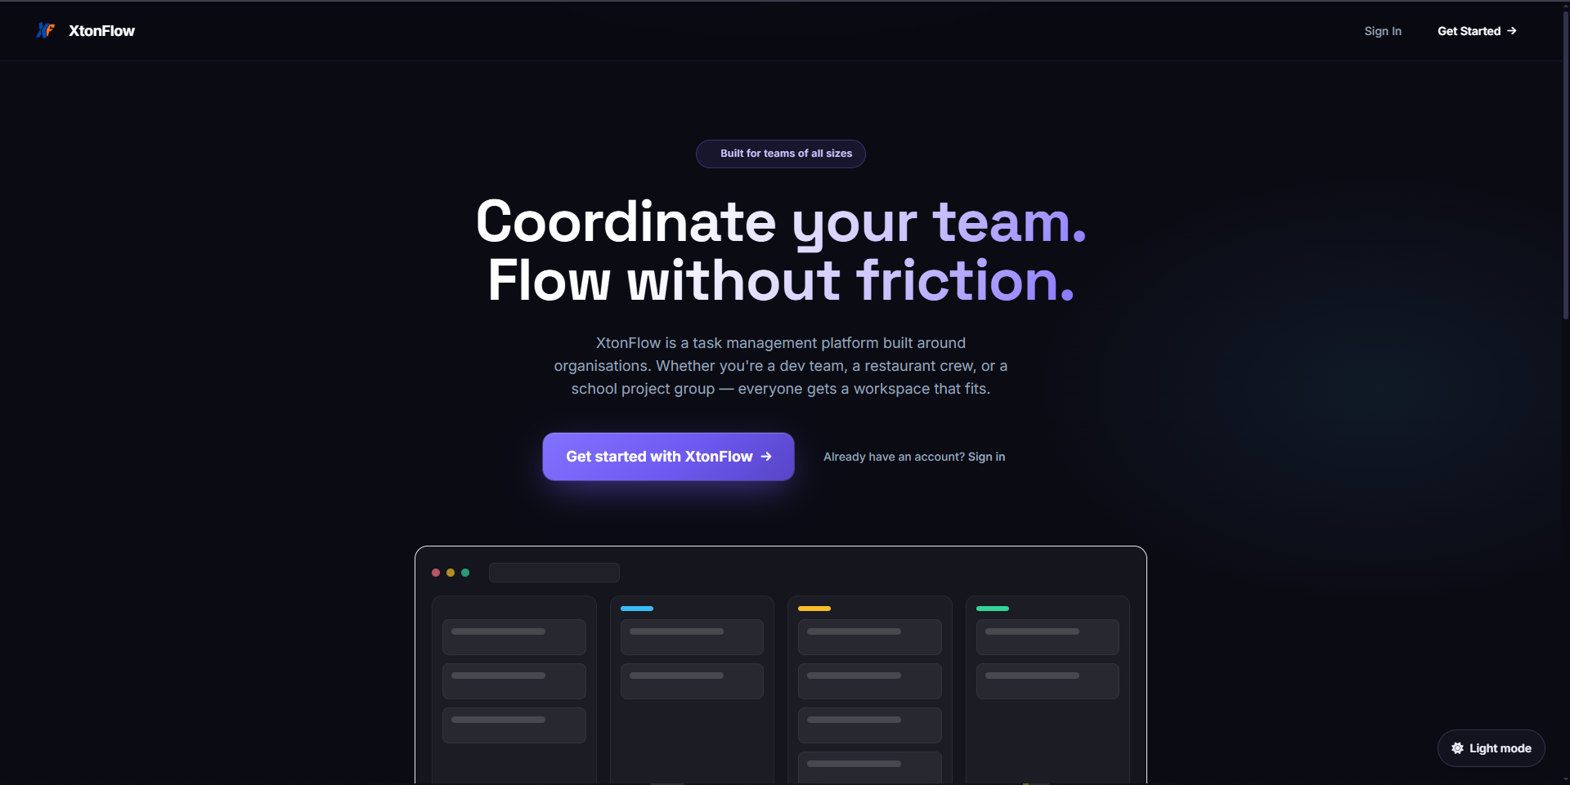

Architecture and Technologies Used
TaskFlow uses a classic three-tier client-server architecture composed of the following layers:
- Frontend – React 19 with Vite as the build tool, styled with Tailwind CSS; client-side routing with React Router; a SockJS/STOMP WebSocket client for real-time updates; Font Awesome for iconography.
- Backend – Java Spring Boot exposing a REST API under /api; Spring Security with JWT-based authentication stored in HttpOnly cookies, together with Google OAuth 2.0 sign-in and email verification handled through SMTP mail; Spring Data JPA for the persistence layer.
- Database – PostgreSQL relational database storing users, organisations, boards and board memberships, tasks, checklist items, comments, attachments and notifications.
- Real-time layer – Spring WebSocket (STOMP) broadcasting task events (created, updated, status changed, deleted) to all connected clients of a board, so every member's view stays synchronised without manual refresh.
- Additional services – disk-based file storage for task attachments, and an email service for account verification and notification messages.
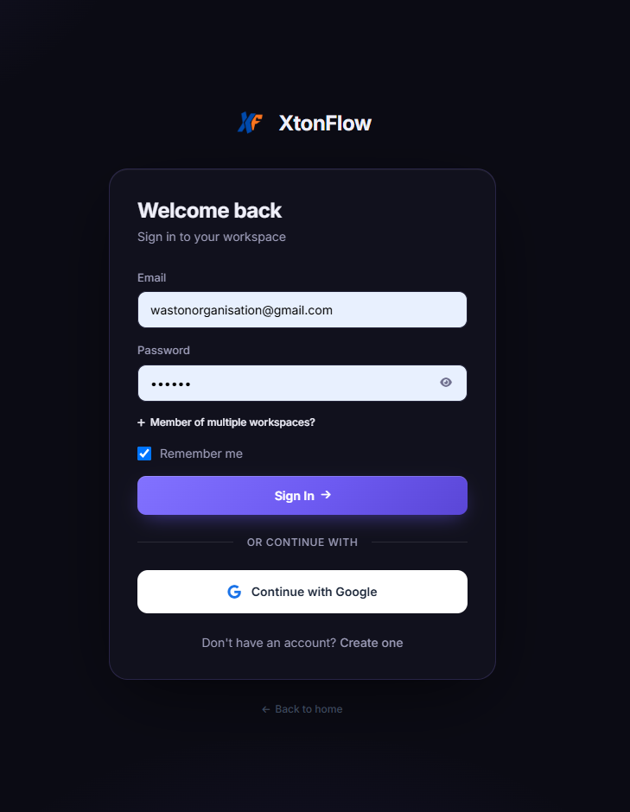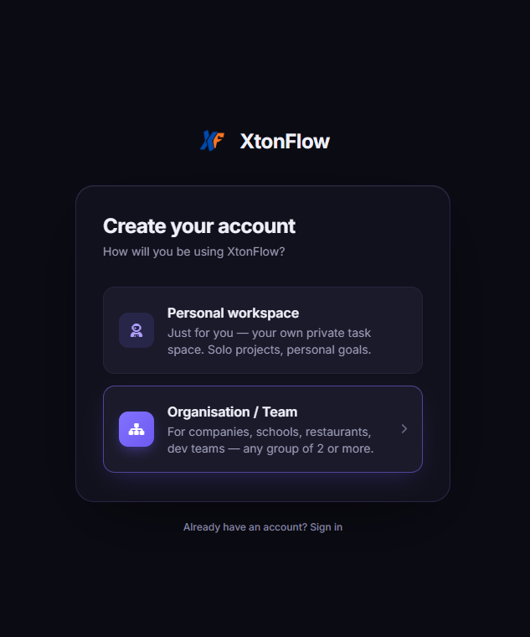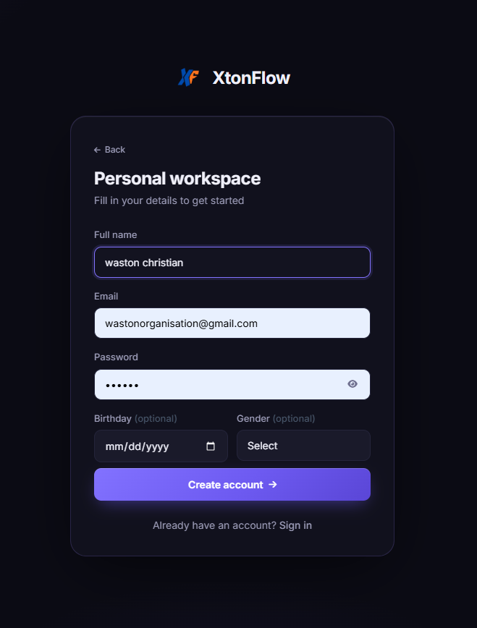

Key Features Implemented
The main functional features I implemented or extended include:
- Organisation and board management with membership: users belong to an organisation, create boards and invite members; every backend resource is authorised per board member, not merely authenticated.
- A Kanban board with four workflow columns (To Do, In Progress, Review, Done), available in three views: board, list and calendar. 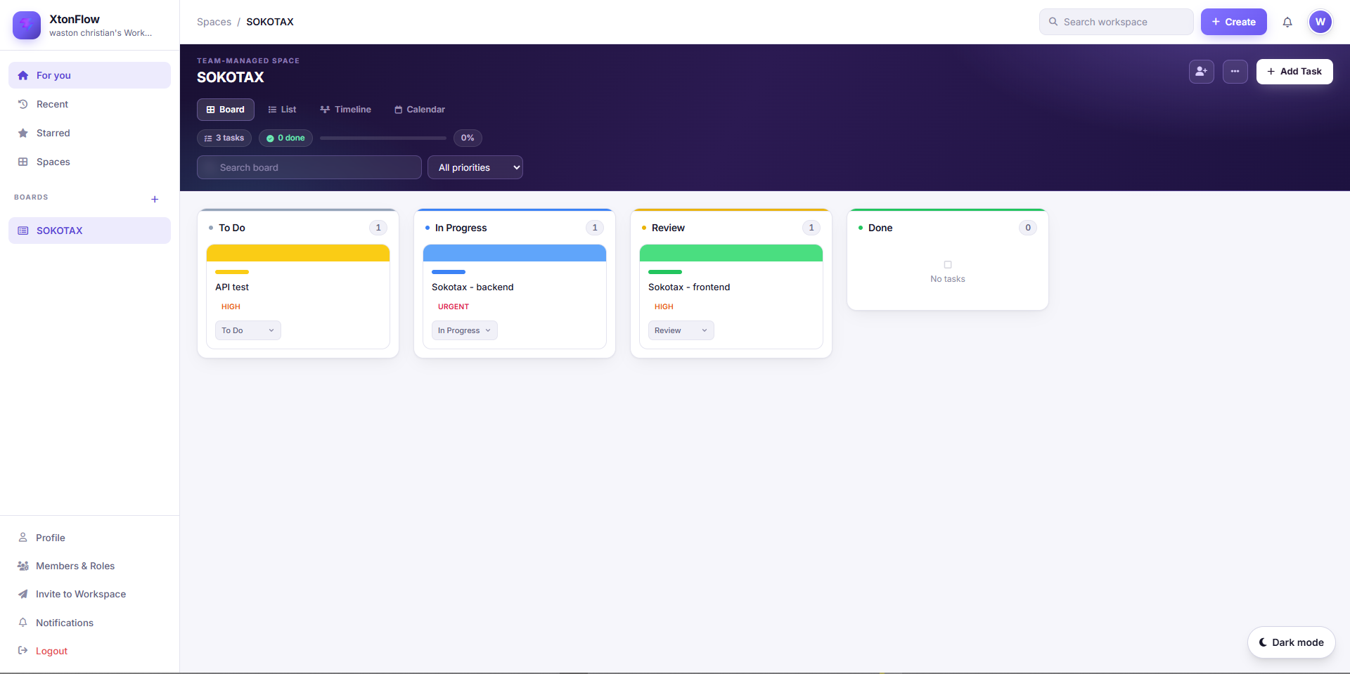
- Rich task cards: title, description, colour labels and cover colours, four priority levels (Urgent, High, Medium, Low), due dates with automatic overdue highlighting, and ordering position.
- Per-task checklists with checked/total counters and progress bars; comments that notify members of changes; file attachments.
- Drag and drop task cards can be dragged between columns and re-ordered inside a column. Status transitions and positions persisted server-side through dedicated REST endpoints, with optimistic UI updates and automatic recovery to the server state if a request fails.
- Real-time collaboration: all task events are broadcast over WebSocket so concurrent users see each other's changes immediately, supported by an in-app notification centre.
- Search and priority filtering, progress statistics per board, a dark/light themed and fully responsive interface, and dashboard navigation.

Development Process
The project was delivered in short iterations following the agile practices used at Osopox. I started from the backend (data model, repository and service layers, then REST controllers), tested the endpoints with Postman, and only then built the corresponding React interface, which kept integration problems minimal. Version control was used throughout; each change was reviewed by my field supervisor before being merged, and his feedback was applied in the next iteration.

Challenges and Solutions
The most instructive challenges involved real-time synchronisation and drag-and-drop ordering. Keeping position values consistent when several users reorder a board concurrently required a dedicated reorder endpoint that receives the complete ordering of a column, rather than sending one move per card. Handling session expiry without breaking the user experience led to a centralised authenticated fetch utility on the frontend that redirects the user to the login page with a friendly banner instead of surfacing raw 401 errors. Both solutions deepened my understanding of building reliable client-server interaction rather than merely working code.

Project Illustrations (Screenshots)
The figures below document the predefined content pages and features of TaskFlow. Each yellow-highlighted marker shows exactly where to insert a screenshot for Project 1. Replace each marker with the corresponding screenshot (and a caption), then delete the marker text.
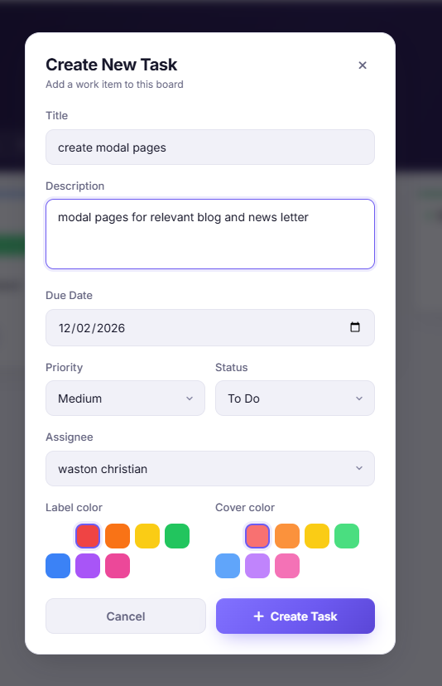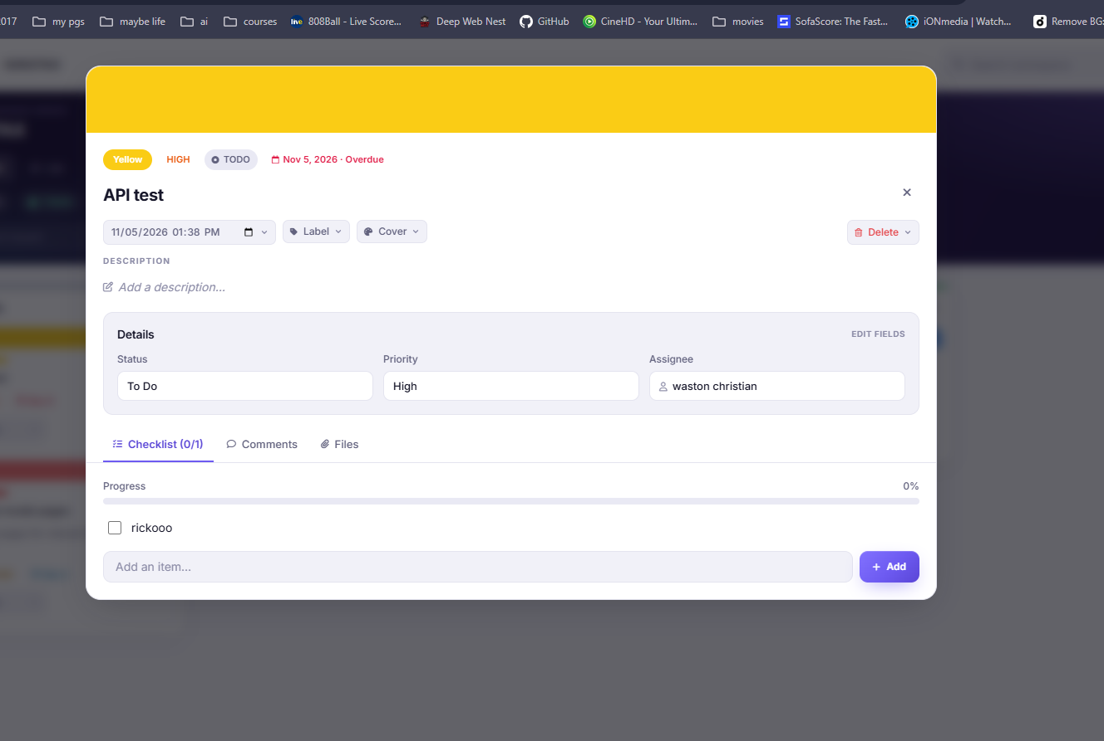
[INSERT SCREENSHOT 5 HERE — the Task Details modal showing description, checklist with progress bar, comments and attachments.]
[INSERT SCREENSHOT 6 HERE — drag and drop in action: a task card being dragged, with the visual drop indicator and the highlighted target column.]
[INSERT SCREENSHOT 7 HERE — the List and Calendar views of the same board (use two numbered figures if space allows).]
[INSERT SCREENSHOT 8 HERE — board statistics area and an open notification, evidencing real-time collaboration between two users.]

3.3 Project 2: SecureAuth API (Microservice)
[To be completed with screenshots and technical details]

3.4 Project 3: Osopox DevPortal (Documentation Hub)
[To be completed with screenshots and technical details]

CHAPTER 4: SWOT ANALYSIS OF OSOPOX
A SWOT analysis is a strategic framework used to evaluate the Strengths, Weaknesses, Opportunities, and Threats of an organization. Based on my internship experience and observations at Osopox, the following analysis was developed.

4.1 Strengths
During my internship I was able to observe most of these strengths first-hand. The engineering side of Osopox works with a clearly separated frontend and backend codebase built on modern technologies such as React and Java Spring Boot, and every feature I worked on went through the hands of a senior developer before being considered complete. Knowledge sharing is part of the daily routine: questions are answered directly, and mentorship is treated as a responsibility rather than a distraction. The same user-centred attention also showed in the products I contributed to, where UI polish, responsiveness and usability were treated as requirements, not afterthoughts.
- Highly skilled and passionate technical team with expertise in modern technologies.
- Agile and flexible work culture that enables rapid product development and iteration.
- Strong focus on user-centered design, resulting in high-quality digital products.
- Diverse service portfolio that caters to multiple industry sectors.
- Hands-on approach to mentorship and knowledge sharing within the team.
- Strong adoption of a clean backend/frontend separation and shared coding standards, which made it possible for an intern to become productive on the production codebase within weeks.

4.2 Weaknesses
These weaknesses did not prevent delivery during my time at Osopox, but I could see how they would amplify each other under pressure. Because knowledge is concentrated in a small number of people, the absence of one senior developer visibly slows down reviews and handovers, and the lack of written procedures means decisions live in chat threads and in people's heads rather than in documents. Internal tools such as the task management application I helped build reduce this risk, but they do not yet fully replace a formal documentation process.
- Limited team size, which can create bottlenecks during high-demand project periods.
- Concentration of institutional knowledge in a few senior developers, with limited written onboarding material, which slows handovers and increases continuity risk.
- Relatively low brand visibility compared to larger, more established competitors.
- Dependency on a small client base, making revenue streams less diversified.
- Limited formal documentation of internal processes and best practices.

4.3 Opportunities
From the inside, the opportunities in this list are not abstract. The work I did on internal tools such as a task management Kanban application shows that the demand for digital productivity tools starts with Osopox's own clients and even its own operations. Products first developed as internal tools can be matured and offered commercially, which turns each internal project into a potential new revenue stream at little extra design cost.
- Rapid digital transformation across Rwanda and the East African region creates growing demand for tech services.
- Government initiatives promoting ICT adoption and innovation (e.g., Rwanda Vision 2050) present partnership opportunities.
- Expansion potential into neighboring markets such as Uganda, DRC, and Kenya.
- Growing startup ecosystem in Kigali provides networking and collaboration opportunities.
- Increasing demand for cloud-based and mobile-first solutions across sectors.
- A growing appetite for collaborative work-management tools, which internal products already demonstrate and which could be positioned as commercial offerings.

4.4 Threats
During the internship I experienced these threats indirectly rather than directly. Small technology firms in the region compete largely on trust and delivery speed, and any delay caused by capacity limits or documentation gaps weakens that trust. Continuous learning was treated internally as a necessity, since the frameworks and libraries we used evolved fast enough that knowledge from even one year earlier could be outdated, which is exactly the pressure that larger, better-funded competitors absorb far more easily.
- Intense competition from both local startups and international technology firms entering the African market.
- Rapid technological change requires continuous upskilling and investment in new tools.
- Economic fluctuations may reduce clients' technology budgets.
- Cybersecurity risks and data privacy concerns increasingly affect client confidence.
- Brain drain — skilled tech professionals may be attracted to larger companies or international opportunities.

4.5 Summary
Overall, Osopox is well-positioned to capitalize on the growing digital economy in Rwanda and the broader East African region. By addressing its internal weaknesses — particularly around team capacity and process documentation — and strategically leveraging the opportunities available, the company has strong potential for sustainable growth. Vigilance against competitive and cybersecurity threats will be critical to long-term success.
For me, the SWOT analysis is also a lens on my own internship: the strengths I relied on (mentorship and modern tooling) accelerated my learning, while the weaknesses I observed (limited documentation) pushed me to take notes, write things down and help close that gap. This personal view of the SWOT factors directly informs the recommendations made in Chapter 5 of this report.

CHAPTER 5: CONCLUSION

5.1 Summary of the Internship Experience
The internship at Osopox was an invaluable and transformative experience that significantly enhanced my understanding of the software development industry. Over the course of the internship period, I had the opportunity to work alongside experienced professionals, contribute to real-world projects, and develop both technical and interpersonal skills that cannot be fully acquired in a classroom setting. From the first day, I was integrated into the team and assigned meaningful tasks that challenged me to apply my academic knowledge while adapting to industry standards and professional workflows. The experience at Osopox reinforced the importance of collaboration, attention to detail, and continuous learning in a fast-paced technology environment.

5.2 Skills and Knowledge Gained
Through this internship, I developed and strengthened the following skills:
- Technical proficiency in software development tools and frameworks used in professional settings.
- Practical experience with version control systems, project management tools, and collaborative workflows.
- Improved problem-solving and debugging skills through hands-on project work.
- Enhanced communication and teamwork skills through daily collaboration with colleagues.
- Greater understanding of client requirements gathering and translating them into technical solutions.
- Exposure to agile development methodologies and their application in a real company context.

5.3 Challenges Encountered
Like any professional experience, the internship came with its share of challenges. Adapting to a new codebase and understanding existing project architecture required patience and persistence. There were moments where tight deadlines demanded efficient time management and prioritization. These challenges, however, were valuable learning opportunities that prepared me for the realities of professional software development.

5.4 Recommendations
Based on my experience, I offer the following recommendations:
- Osopox should consider expanding its team to manage growing project demands more effectively.
- A formal onboarding and documentation process for new interns and employees would improve knowledge transfer.
- AUCA should continue strengthening industry partnerships to provide students with diverse and high-quality internship placements.
- Future interns should arrive prepared with strong foundational skills in web development and version control.

5.5 Final Remarks
In conclusion, the internship at Osopox was a highly rewarding experience that achieved its intended objectives. It provided a solid bridge between academic learning and professional practice, and I am confident that the skills, experiences, and insights gained will serve as a strong foundation for my future career in technology. I am grateful to AUCA for facilitating this opportunity and to the entire Osopox team for their support, guidance, and mentorship throughout the internship period.

